 A.D.PATEL INSTITUTE OF TECHNOLOGY

PROJECT REPORT
STUDENT ATTENDANCE MANAGEMENT SYSTEM

Subject :DATABASE MANAGEMENT SYSTEM (DBMS)
Name :Mistry Hit M (26D2DIT006)
:Parmar shrey s (26D2DIT007)
:Rana jaimin (12502080601040)
:Patel Jayam (12502080601045)

Department / Branch:INFORMATION TECHNOLOGY
Submission Date: ________________________________
Academic Year: 2026–2027

Table of content
A.D.PATEL INSTITUTE OF TECHNOLOGY 1
CERTIFICATE 3
ACKNOWLEDGEMENT 4
ABSTRACT 5
CHAPTER 1: INTRODUCTION & SYSTEM REQUIREMENTS 6
1.1 Background 6
1.2 Scope of the Project 6
1.3 Hardware and Software Specifications 6
CHAPTER 2: DATABASE DESIGN 7
2.1 Requirement Analysis and Business Rules 7
Business Rules 7
2.2 ER Diagram 7
2.3 Relational Schema Mapping 8
2.4 Normalization Analysis (1NF, 2NF, 3NF) 8
CHAPTER 3: IMPLEMENTATION & SQL SCRIPTS 9
3.1 Data Definition Language (DDL) Scripts 9
Students Table 9
Courses Table 9
Attendance_Logs Table 9
3.2 Data Manipulation Language (DML) & Analytical Queries 10
Query 1: Attendance Summary 10
Query 2: Students Below 75% 10
Query 3: Absentees for a Selected Date 10
Query 4: Faculty and Assigned Courses 10
CHAPTER 4: SCREEN LAYOUTS & TEST RESULTS 11
4.1 Interface / Form Screenshots 11
4.2 Sample Output Reports / Query Results 12
CHAPTER 5: CONCLUSION & REFERENCES 15
5.1 Summary 15
5.2 Limitations & Future Improvements 15
5.3 References / Sources 15

CERTIFICATE

This is to certify that the DBMS micro-project entitled “Student Attendance Management System” has been prepared and submitted by the team members listed on the title page as part of the academic work for the subject Database Management System (DBMS).
The project demonstrates relational database concepts through the design of tables for students, faculty, courses and attendance records. It includes primary and foreign keys, integrity constraints, SQL queries, attendance summaries and testing examples. The project is submitted for academic evaluation.

Signature: __________________________ Date: ______________________________

ACKNOWLEDGEMENT

We would like to thank our DBMS faculty for explaining the database concepts that helped us plan and prepare this micro-project. Topics such as relational tables, primary keys, foreign keys, constraints, joins, aggregate functions and views became easier to understand when we applied them to a practical problem.
We are also thankful to our institute for giving us the opportunity to complete this project as part of our coursework. While working on the Student Attendance Management System, we learned how attendance information can be organised in a database instead of being maintained only in registers or separate spreadsheets. We understood the importance of keeping student, course and faculty details separate and connecting them through key fields.
Finally, we acknowledge the official SQLite and Python documentation and the project files used during development. The guidance and resources helped us understand the structure of the database and the purpose of the SQL queries included in this report.

ABSTRACT

The Student Attendance Management System is a database-based project designed to maintain attendance records in an organised and consistent way. Manual attendance registers and separate spreadsheets can take time to search, and repeated calculations may lead to errors. The system stores student details, faculty details, courses and daily attendance records in related tables. Primary keys identify records, while foreign keys connect the tables. UNIQUE and CHECK constraints help prevent duplicate or invalid data. SQL queries are used to calculate attendance percentages, identify students below the required attendance level, list absentees for a selected date and prepare course-wise summaries. The supplied project uses SQLite as its database engine and includes SQL files, sample data, a Python command-line application, a Tkinter desktop interface and a browser-based interface. The project is intended for learning and demonstration of DBMS concepts. The sample attendance categories are project rules and should be adjusted to match the official policy of the institution.

CHAPTER 1: INTRODUCTION & SYSTEM REQUIREMENTS

1.1 Background
Attendance is an important part of academic administration. Colleges need to record whether a student attends each lecture and use those records to prepare reports. As the number of students, subjects and teaching days increases, maintaining attendance manually becomes more difficult. Faculty may need to check a student's attendance in one subject, prepare a list of students below the required percentage, or find who was absent on a particular day.
The Student Attendance Management System uses a relational database to keep this information in a structured form. Student details are stored separately from course and faculty details. Each attendance entry connects a student with a course and a date. This reduces repeated information and makes records easier to update and search.

1.2 Scope of the Project
The project focuses on storing student, faculty and course details, recording daily attendance, and producing attendance summaries. It demonstrates SQL table creation, constraints, joins, aggregate functions and views. The supplied package includes local SQLite database files and interfaces for command-line, desktop and browser-based demonstration.
The current scope does not include biometric devices, institution-wide login security, automatic timetable synchronisation, college ERP integration or a central multi-user server. These features may be considered in a future version.

1.3 Hardware and Software Specifications
Type | Requirement / Technology
Hardware | A standard desktop computer or laptop; internet access is only needed for downloading tools or documentation.
Database engine | SQLite — the supplied project uses SQLite syntax and a local database.
SQL files | schema.sql, sample_data.sql and queries.sql.
Desktop interface | Python 3 with Tkinter (gui_app.py).
Command-line interface | Python 3 (main.py).
Browser interface | HTML and JavaScript (attendance_app.html).
Editor | Visual Studio Code or another text/code editor.

CHAPTER 2: DATABASE DESIGN

2.1 Requirement Analysis and Business Rules
The database must store and retrieve student, faculty and course information. It must record whether a student was Present or Absent for a course on a given date, display attendance for a selected course and date, calculate percentages, and identify records below the defined threshold. The design should also prevent duplicate daily attendance entries and keep links between related records valid.

Business Rules
- Each student has a unique student ID and roll number.
- Each faculty member has a unique faculty ID and email address.
- Each course has a unique course ID and course code and is assigned to a faculty member.
- Each attendance entry refers to an existing student, course and faculty member.
- Attendance status can be Present or Absent only.
- A student can have only one attendance record for the same course on the same date.
- The sample report treats 75% or more as Eligible, 65% to below 75% as Condonation, and below 65% as Detained. These are project rules, not a substitute for official college policy.

2.2 ER Diagram
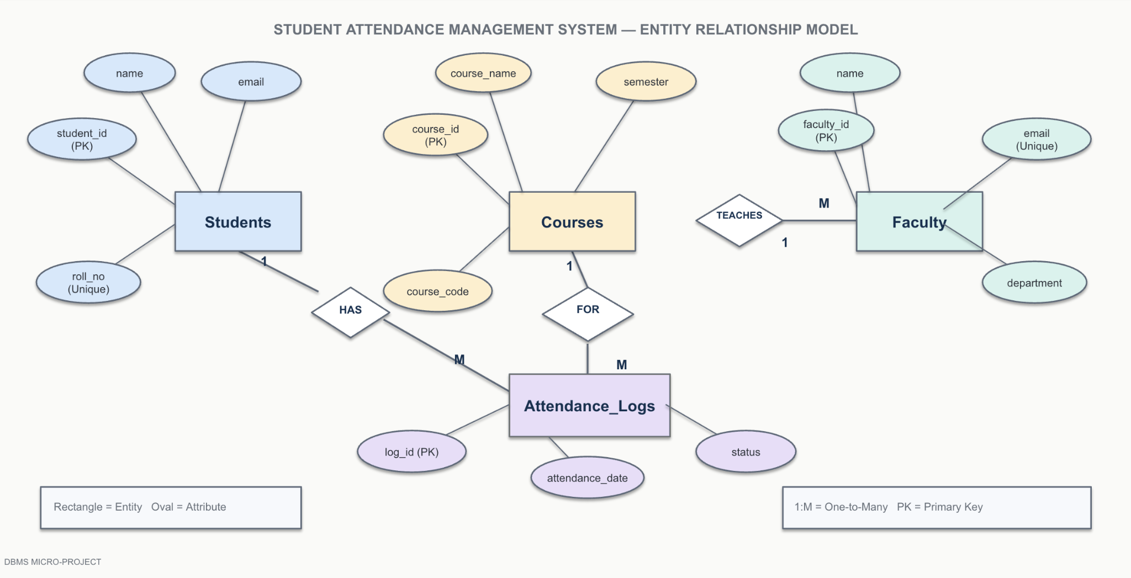

2.3 Relational Schema Mapping
The ER model is mapped to relational tables. Primary keys uniquely identify rows and foreign keys maintain relationships across tables.
Students(student_id PK, roll_no UNIQUE, name, email, department, semester)
Faculty(faculty_id PK, name, email UNIQUE, department)
Courses(course_id PK, course_code UNIQUE, course_name, credits, department,
semester, faculty_id FK)
Attendance_Logs(log_id PK, student_id FK, course_id FK, marked_by FK,
attendance_date, status,
UNIQUE(student_id, course_id, attendance_date))

2.4 Normalization Analysis (1NF, 2NF, 3NF)
First Normal Form (1NF): Each field contains a single value. For example, a student row stores one roll number and one email rather than a list of values in a single field.
Second Normal Form (2NF): Descriptive details are stored with the key that identifies the record. Student names and contact details remain in Students rather than being repeated in every attendance entry.
Third Normal Form (3NF): Faculty and course details are separated into their own tables. Attendance_Logs refers to the related records through foreign keys instead of repeating faculty emails or course names. This reduces unnecessary duplication and makes updates more consistent.

CHAPTER 3: IMPLEMENTATION & SQL SCRIPTS

3.1 Data Definition Language (DDL) Scripts
DDL statements define the structure of the database. The following examples use SQLite syntax, matching the supplied project.

Students Table
CREATE TABLE Students (
student_id INTEGER PRIMARY KEY AUTOINCREMENT,
roll_no TEXT NOT NULL UNIQUE,
name TEXT NOT NULL,
email TEXT UNIQUE,
department TEXT NOT NULL,
semester INTEGER NOT NULL CHECK (semester BETWEEN 1 AND 8)
);

Courses Table
CREATE TABLE Courses (
course_id INTEGER PRIMARY KEY AUTOINCREMENT,
course_code TEXT NOT NULL UNIQUE,
course_name TEXT NOT NULL,
credits INTEGER NOT NULL CHECK (credits > 0),
department TEXT NOT NULL,
semester INTEGER NOT NULL CHECK (semester BETWEEN 1 AND 8),
faculty_id INTEGER NOT NULL,
FOREIGN KEY (faculty_id) REFERENCES Faculty(faculty_id)
);

Attendance_Logs Table
CREATE TABLE Attendance_Logs (
log_id INTEGER PRIMARY KEY AUTOINCREMENT,
student_id INTEGER NOT NULL,
course_id INTEGER NOT NULL,
marked_by INTEGER NOT NULL,
attendance_date TEXT NOT NULL,
status TEXT NOT NULL CHECK (status IN ('Present', 'Absent')),
FOREIGN KEY (student_id) REFERENCES Students(student_id),
FOREIGN KEY (course_id) REFERENCES Courses(course_id),
FOREIGN KEY (marked_by) REFERENCES Faculty(faculty_id),
UNIQUE (student_id, course_id, attendance_date)
);
The complete project also defines the Faculty table, indexes and the v_attendance_summary view. The UNIQUE constraint prevents duplicate attendance for the same student, course and date; CHECK constraints restrict invalid values.

3.2 Data Manipulation Language (DML) & Analytical Queries

Query 1: Attendance Summary
SELECT roll_no, student_name, course_code,
total_classes, classes_attended, percentage, criteria_status
FROM v_attendance_summary
ORDER BY roll_no, course_code;

Query 2: Students Below 75%
SELECT roll_no, student_name, course_code, percentage, criteria_status
FROM v_attendance_summary
WHERE percentage < 75
ORDER BY percentage;

Query 3: Absentees for a Selected Date
SELECT s.roll_no, s.name, c.course_code, al.attendance_date
FROM Attendance_Logs al
JOIN Students s ON s.student_id = al.student_id
JOIN Courses c ON c.course_id = al.course_id
WHERE al.status = 'Absent'
AND c.course_code = 'EE501'
AND al.attendance_date = '2026-10-23';

Query 4: Faculty and Assigned Courses
SELECT f.name AS faculty, c.course_code, c.course_name
FROM Faculty f
JOIN Courses c ON c.faculty_id = f.faculty_id
ORDER BY f.name;
These queries demonstrate SELECT, WHERE, JOIN, GROUP BY, aggregate functions and views. A view stores a reusable SELECT definition rather than a separate copy of report data.

CHAPTER 4: SCREEN LAYOUTS & TEST RESULTS

4.1 Interface / Form Screenshots
The supplied project package includes three ways to demonstrate the system: a Python command-line menu, a Tkinter desktop interface and a browser interface. The command-line and desktop versions use the local SQLite database; the browser version stores its data separately in browser storage unless it has been connected to the same database.
Interface | How it is opened | What to show during demonstration
Command-line | Run `python main.py` in the project folder. | Menu options, adding or viewing records, and query results.
Desktop GUI | Run `python gui_app.py`. | Forms or menus used to manage records and attendance.
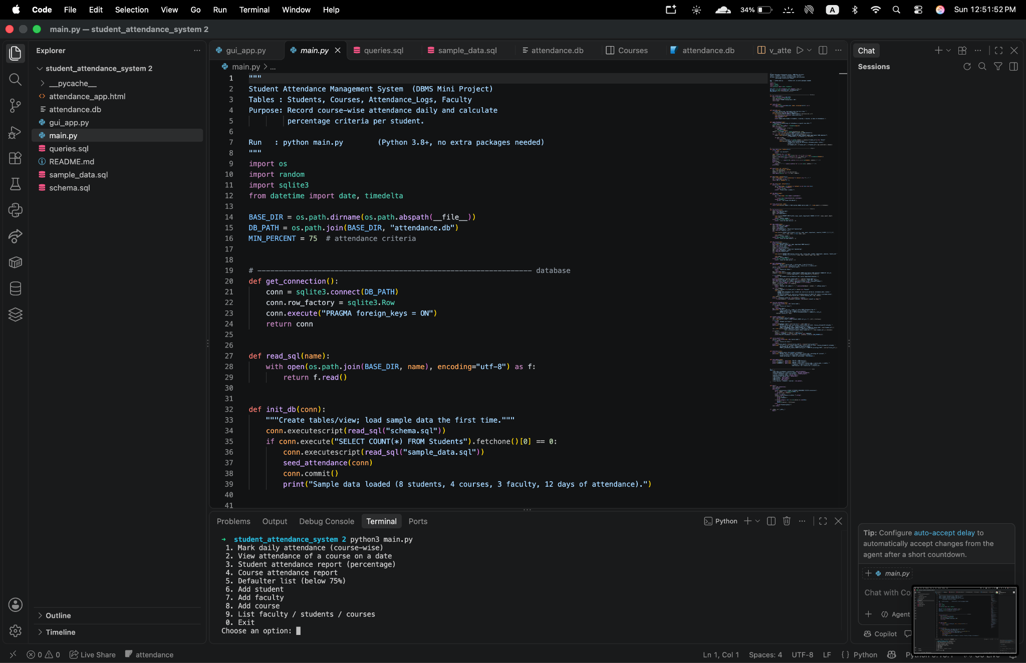

4.2 Sample Output Reports / Query Results
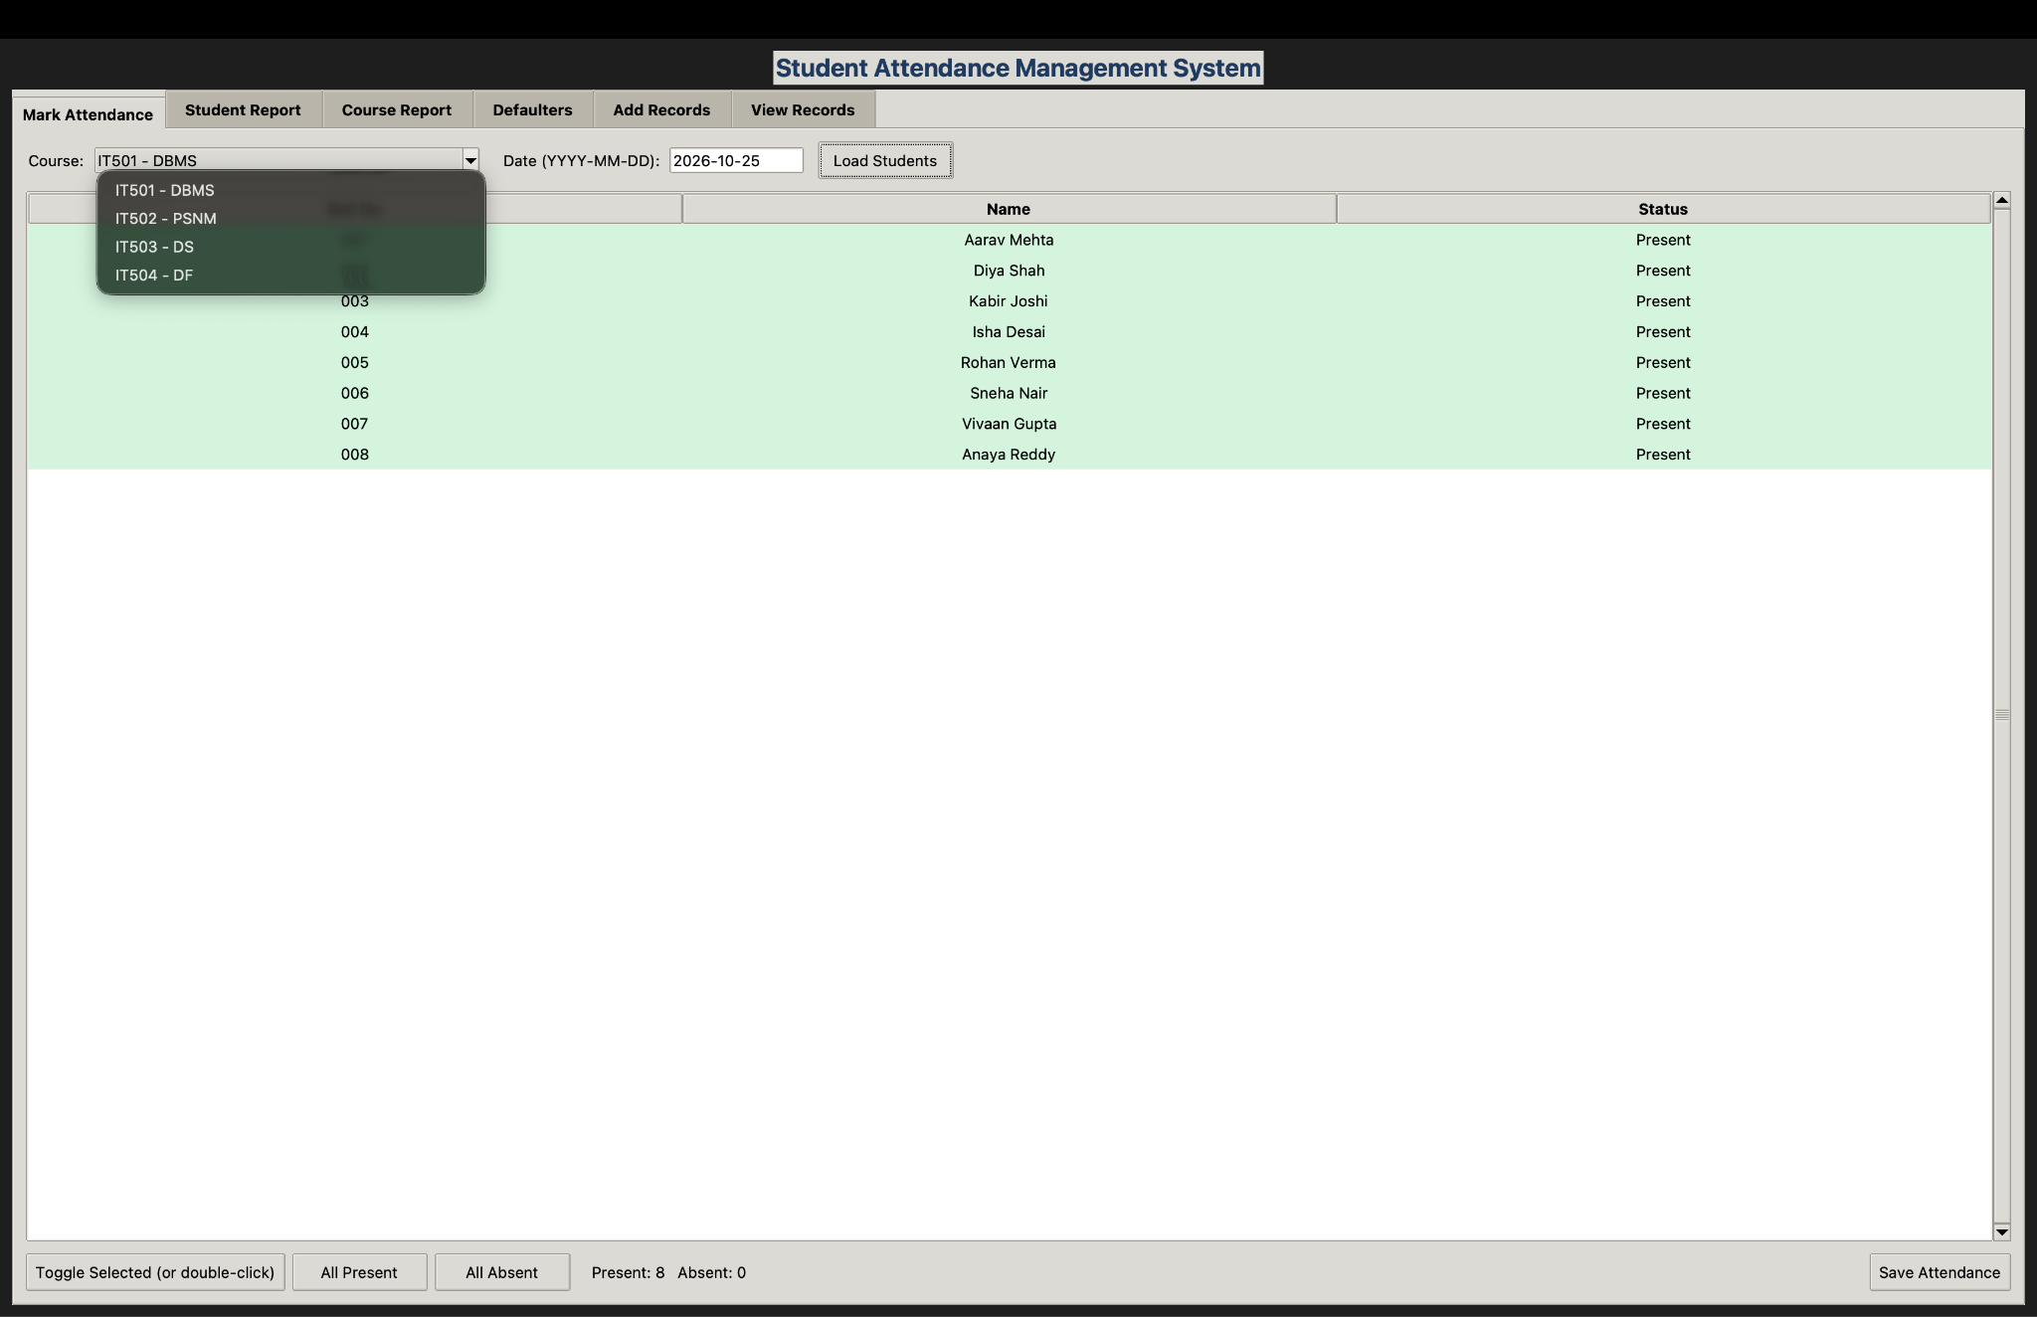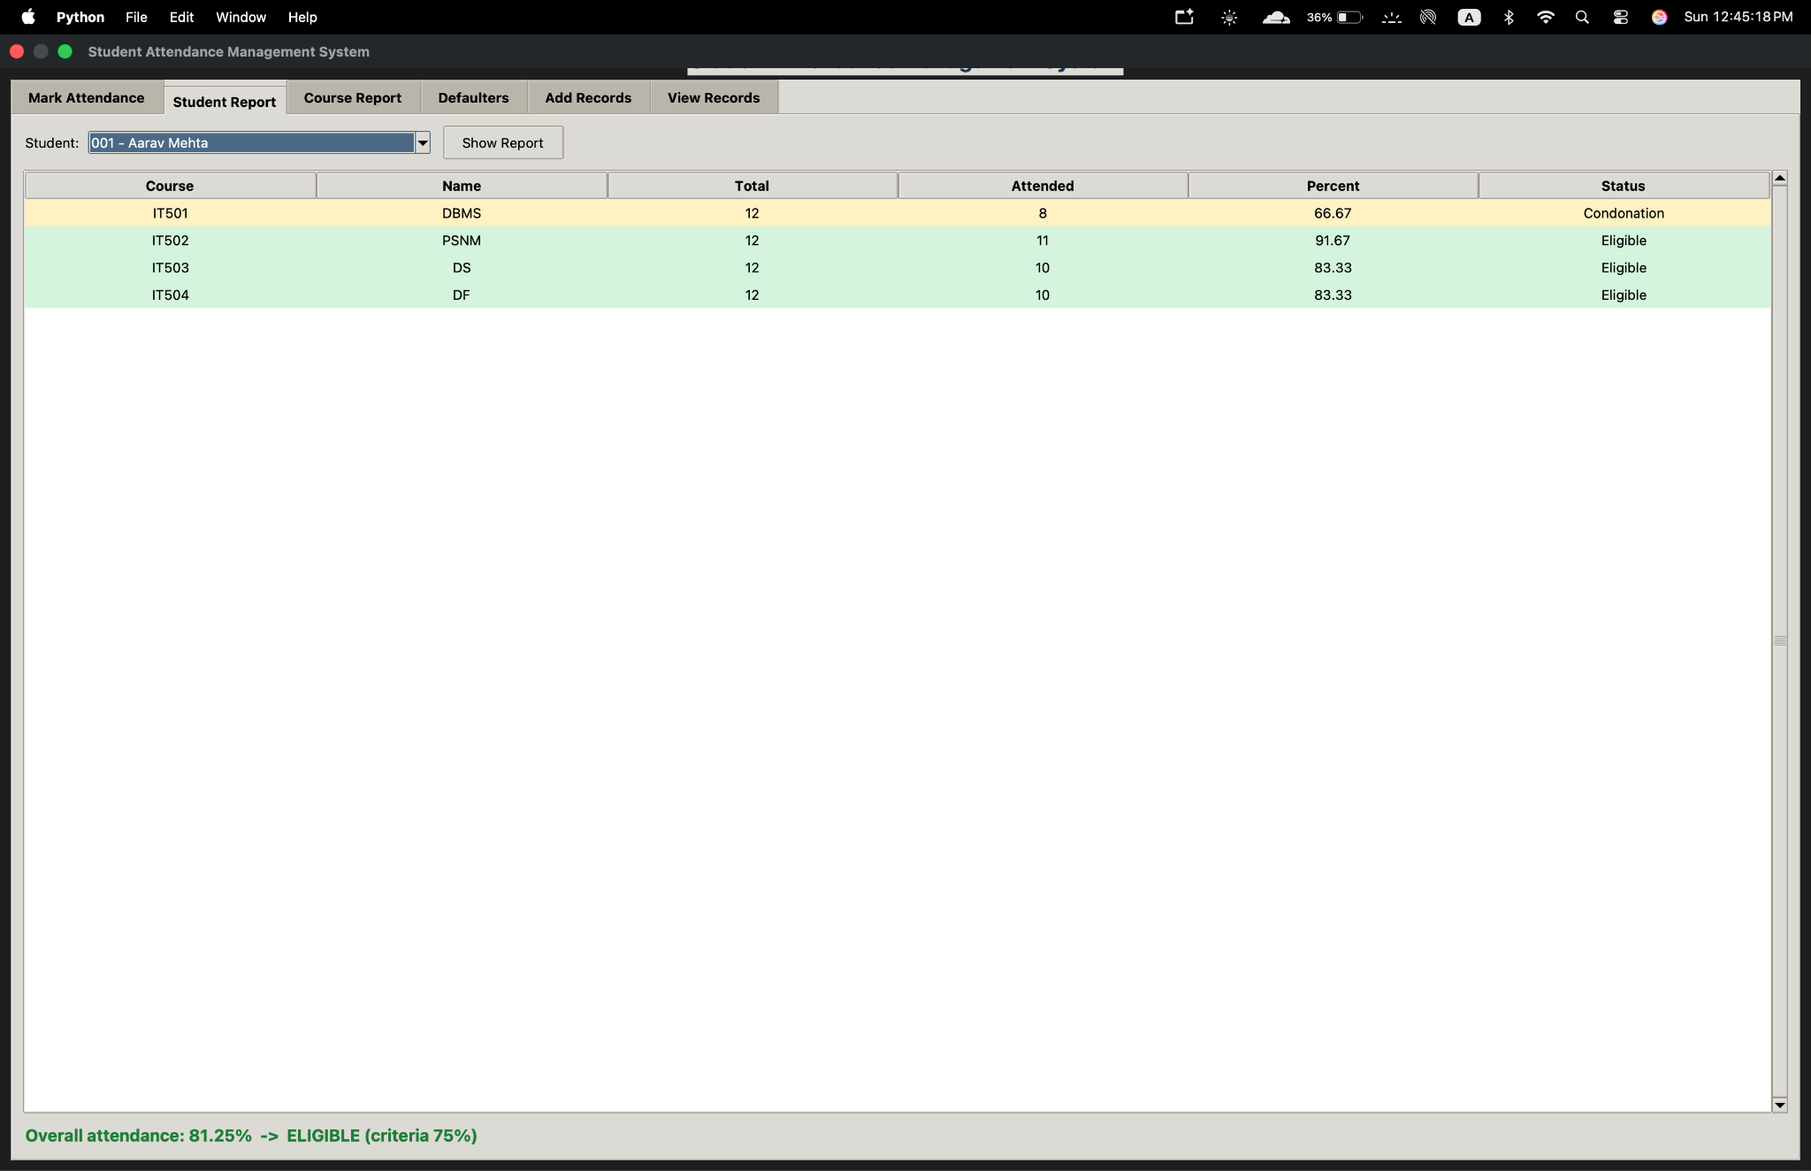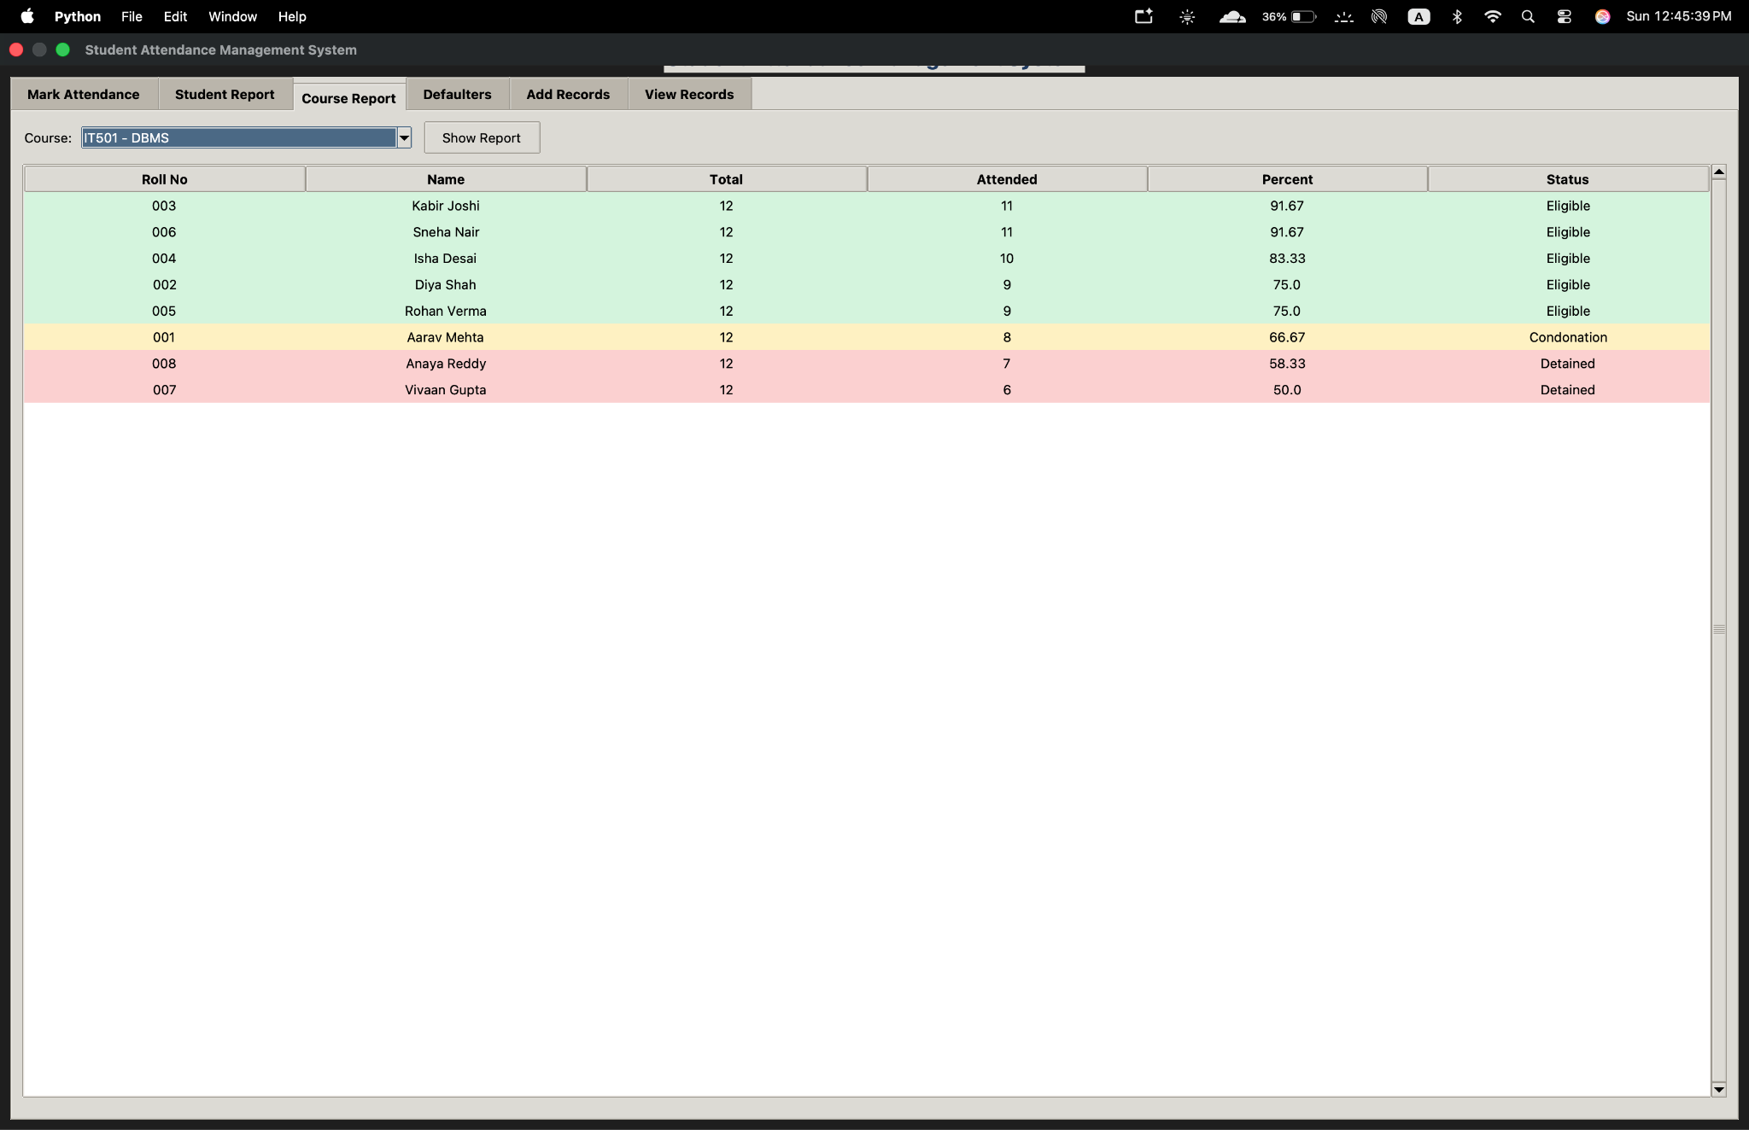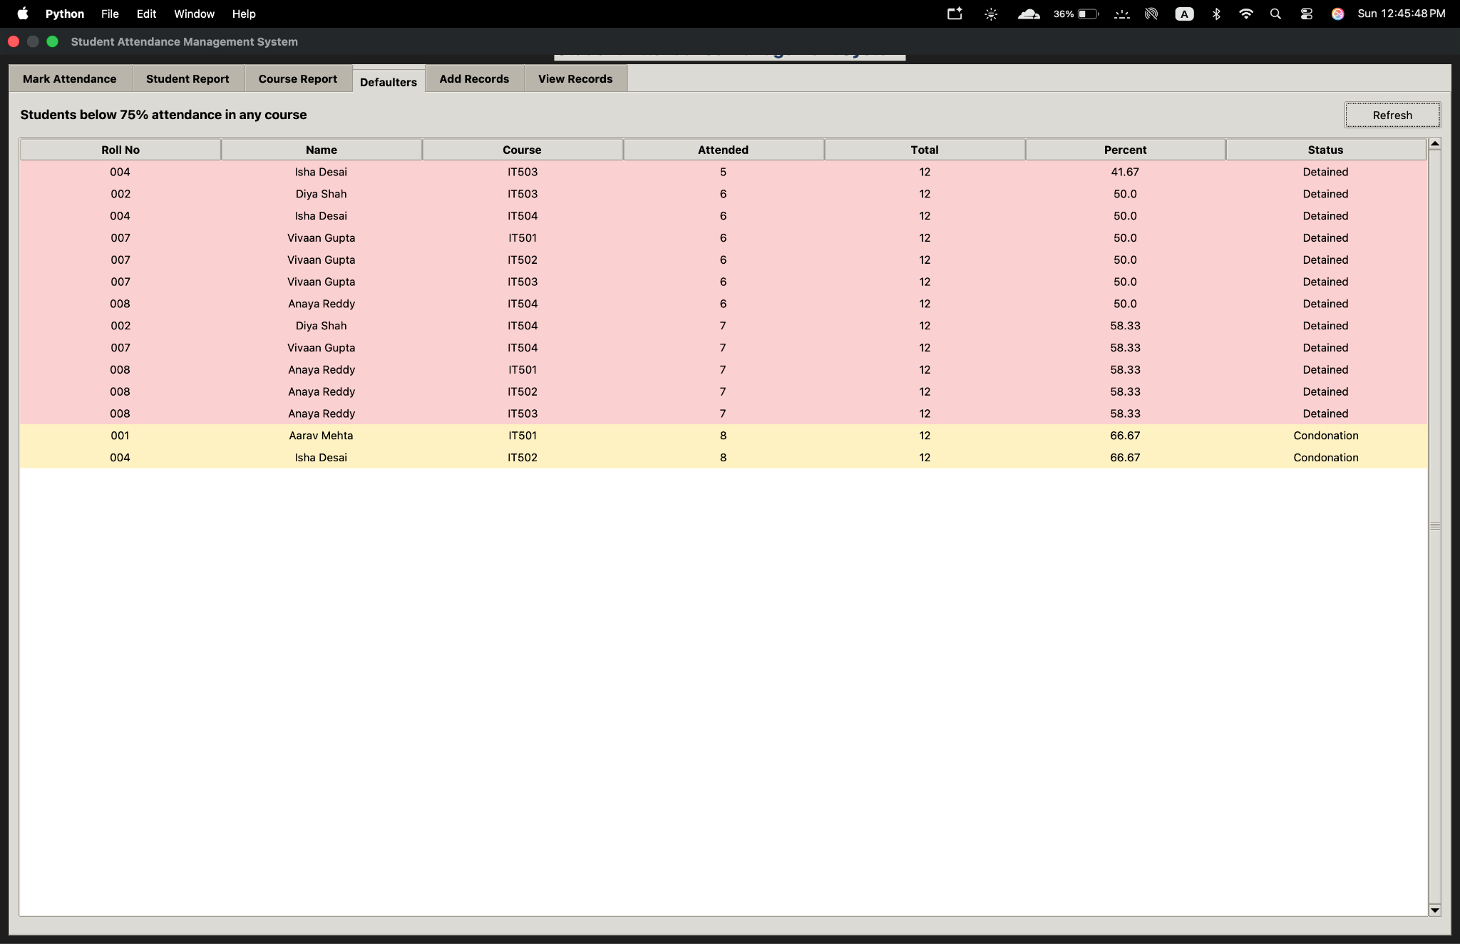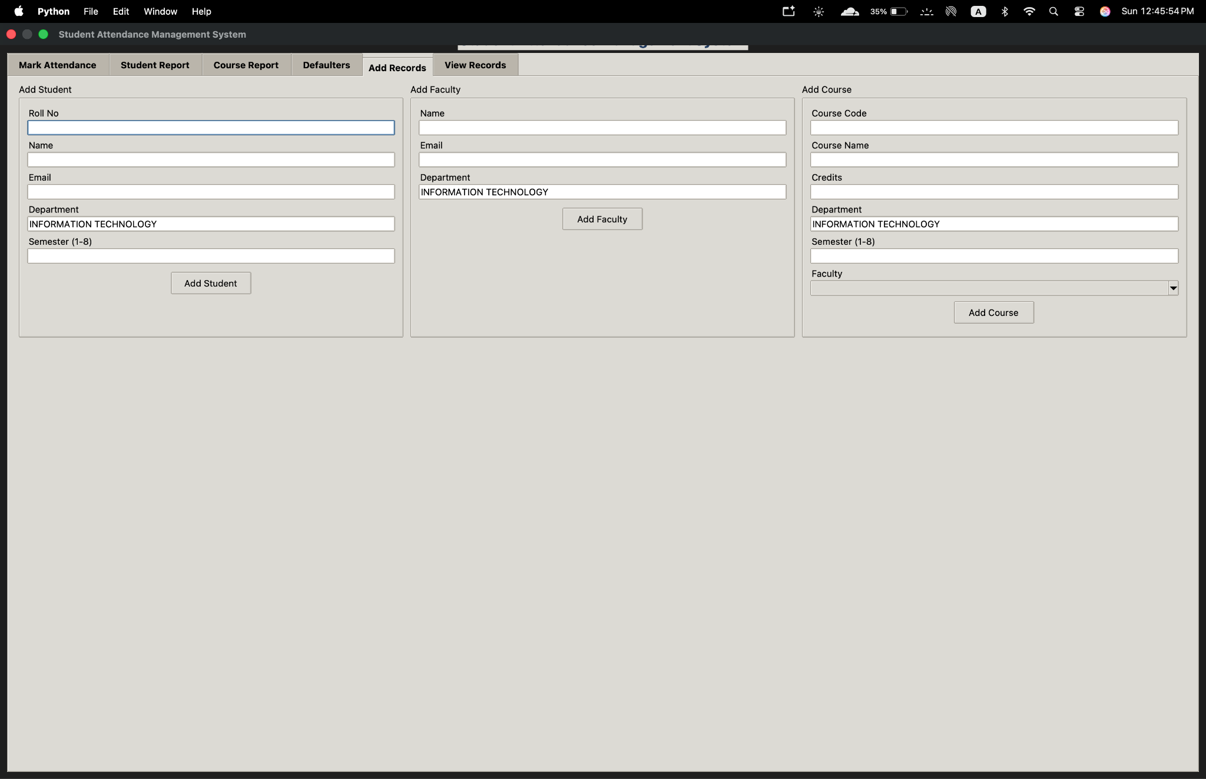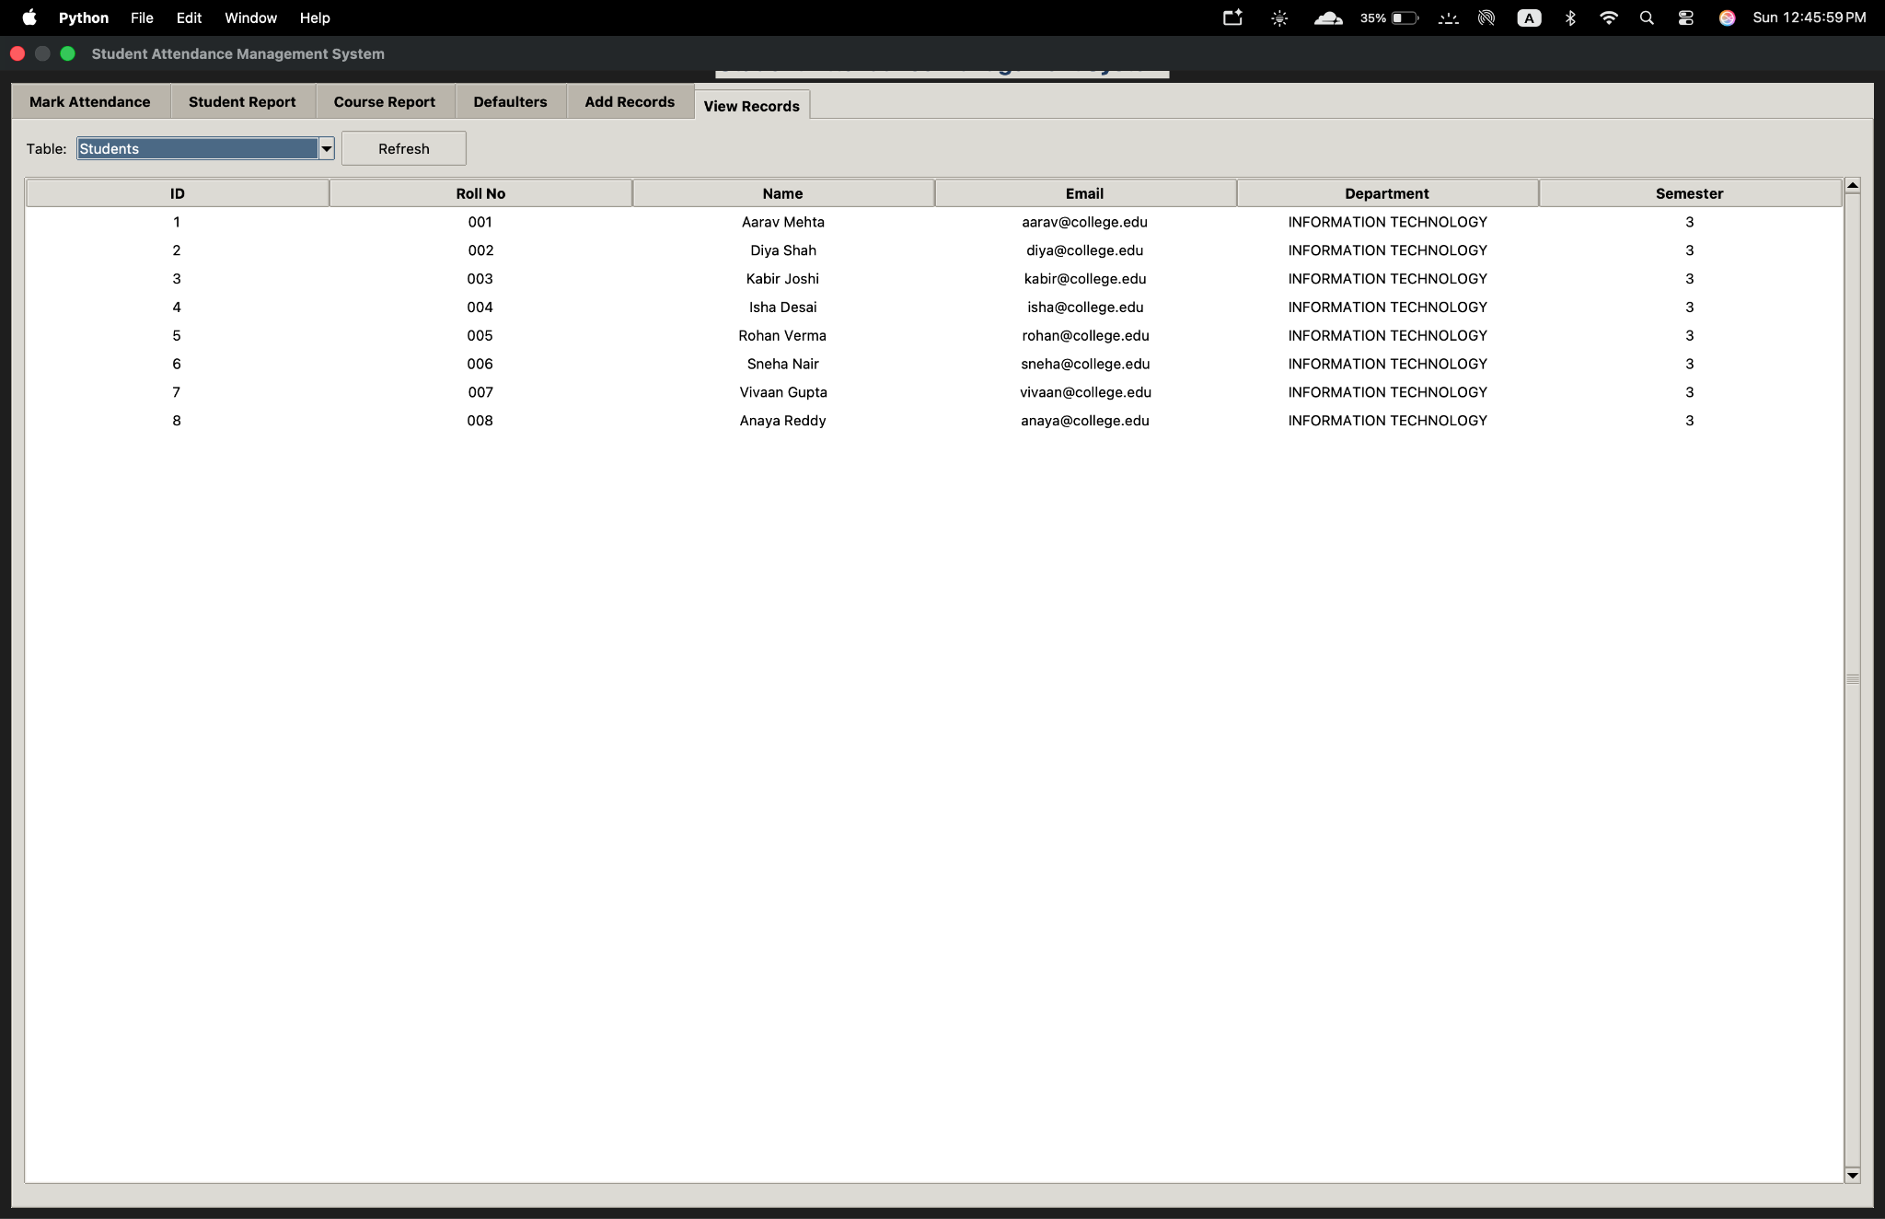

CHAPTER 5: CONCLUSION & REFERENCES

5.1 Summary
The Student Attendance Management System demonstrates how a relational database can support a common academic task. It stores student, faculty and course information in separate tables and connects them using primary and foreign keys. Daily attendance is stored in Attendance_Logs, where constraints restrict invalid statuses and prevent duplicate entries for the same student, course and date.
SQL queries combine related tables, calculate attendance totals and percentages, and identify students whose attendance falls below a defined threshold. The project shows the practical use of DDL, DML, joins, aggregate functions, views, constraints and normalization. It also provides a clear example of how database design can make routine record management more consistent.

5.2 Limitations & Future Improvements
The current package is a local SQLite demonstration and does not provide institution-wide authentication, role-based access control, a central multi-user database or biometric attendance. The sample data and attendance categories are illustrative and may not match a real college's records or policy.
- Convert the schema and queries to MySQL if MySQL Workbench is required.
- Add separate login roles for administrators, faculty and students.
- Connect attendance entry with a timetable and scheduled lectures.
- Provide downloadable PDF or Excel reports by course, semester and date range.
- Maintain audit logs showing who changed a record and when.
- Add alerts for students approaching the minimum attendance requirement and implement regular backups.

5.3 References / Sources
- SQLite Documentation. https://www.sqlite.org/docs.html
- Python Documentation. https://docs.python.org/3/
- Python Tkinter Documentation. https://docs.python.org/3/library/tkinter.html
- Project files supplied with the micro-project: README.md, schema.sql, sample_data.sql, queries.sql, main.py, gui_app.py and attendance_app.html.

